Project Planning Phase

Project Planning Template (Product Backlog, Sprint Planning, Stories, Story points)

Team ID : NM2025TMID08544
Team Size : 4
Team Leader : Varsha R
Team member : Venu K C
Team member : Varun Vikas K
Team member : Nighilkrishna M

Product Backlog, Sprint Schedule, and Estimation:

Sprint | Functional Requirement (Epic) | User Story Number | User Story / Task | Story Points | Priority | Team Members
Sprint-1 | Foundation & Data Structure | USN-1 | Governance Setup: Initiate project traceability by establishing and activating the "Laptop Request" Local Update Set to capture all configuration elements. | 1 | High | Prabhaharan D
Sprint-1 | Foundation & Data Structure | USN-2 | Catalog Item Creation: Build the fundamental Service Catalog item, title it "Laptop Request," and classify it under the Hardware category for user accessibility. | 2 | High | Vishnukumar S
Sprint-1 | Foundation & Data Structure | USN-3 | Variable Definition: Implement the foundational data collection framework by defining the four core variables (laptop_model, justification, additional_accessories  , accessories_details) on the catalog form. | 3 | High | Pavankanth V  and Mohammed Arsath K

Sprint-2 | Dynamic Form Logic | USN-4 | Dynamic Policy Implementation: Develop the necessary Catalog UI Policy logic to control visibility and mandatory status of the 'Accessories Details' field based on the 'Additional Accessories' checkbox selection. | 5 | High | Vishnukumar S
Sprint-2 | Dynamic Form Logic | USN-5 | UX Reset Action: Implement the client-side 'Reset Form' UI Action on the sc_cart table to provide users with a  rapid method to clear all input fields and restart the request. | 3 | Medium | Prem Kumar M V
Sprint-3 | Deployment & Validation | USN-6 | Deployment Preparation: Finalize the artifact for migration by marking the Update Set as Complete and exporting the solution package to an XML file. | 1 | High | Vishnukumar S
Sprint-3 | Deployment & Validation | USN-7 | Functional Testing: Execute end-to-end validation, including verification of dynamic form behavior, mandatory field enforcement, and the correct function of the 'Reset Form' client script. | 4 | High | Prabhaharan D

Project Tracker, Velocity & Burndown Chart:

Sprint | Total Story Points | Duration | Sprint Start Date | Sprint End Date (Planned) | Story Points Completed (Actual) | Sprint Release Date (Actual)
Sprint-1 | 6 | 1 Day | 25 Oct  2025 | 25 Oct 2025 | 6 | 25 Oct 2025
Sprint-2 | 8 | 1 Day | 26 Oct  2025 | 26 Oct 2025 | 8 | 26 Oct 2025
Sprint-3 | 5 | 1 Day | 27 Oct  2025 | 27 Oct 2025 | 5 | 27 Oct 2025
Total | 19 | 3 days |  |  | 19

Velocity:
𝑇𝑜𝑡𝑎𝑙 𝑆𝑡𝑜𝑟𝑦 𝑃𝑜𝑖𝑛𝑡𝑠 𝐶𝑜𝑚𝑝𝑙𝑒𝑡𝑒𝑑
𝐴𝑣𝑒𝑟𝑎𝑔𝑒 𝑉𝑒𝑙𝑜𝑐𝑖𝑡𝑦 =
𝑇𝑜𝑡𝑎𝑙 𝐷𝑢𝑟𝑎𝑡𝑖𝑜𝑛 𝑖𝑛 𝐷𝑎𝑦𝑠

Total: 19 points over 3 days → Velocity = 6.33 points/day
Burndown Chart:
A burn down chart is a graphical representation of work left to do versus time. It is a critical Agile metric used to track whether the development team is on pace to complete the entire backlog (19 points) within the allocated timeframe (3 days). The chart compares the ideal, linear reduction of work against the actual daily progress.

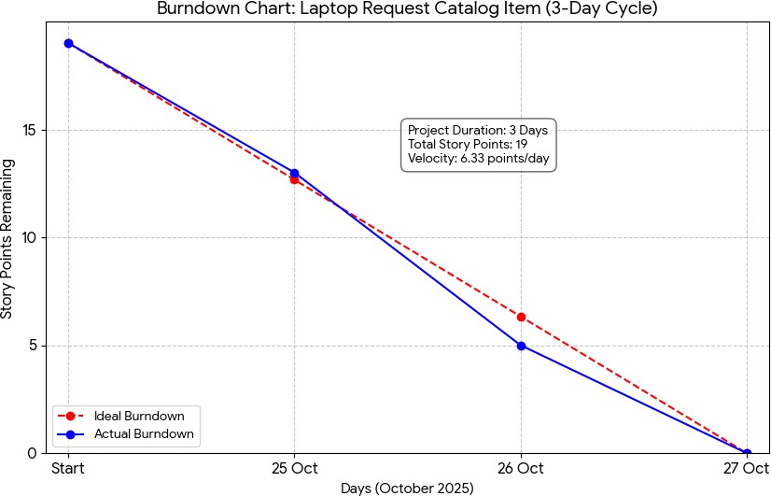

Burndown Chart Creation Process:
- Ideal Burndown (Red Dashed Line): The line starts at 19 points on Oct 25 and must linearly decrease to 0 points by the project end date of Oct 27.
- Ideal Daily Rate: 19 points / 3 days ≈ 6.33 points/day.
- The line has a steeper slope, indicating the aggressive pace required, where the team must complete a substantial amount of work each day to meet the short deadline.
- Actual Burndown (Blue Solid Line): This line reflects the remaining work at the end of each day, based on your planned sprint completions (19 → 13 → 5 → 0 points).
- Visual Interpretation: The blue line must closely follow the steep ideal line. If the team falls behind on any given day, the gap between the blue and red lines will open significantly, which highlights the high risk associated with this short execution window.
- Velocity: 6.33 points/day. This high velocity demonstrates the aggressive nature of the plan.

